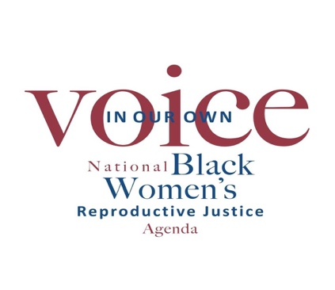
Reproductive Justice State Enhancement Initiative:
Organizational Development and Capacity-Building, Policy and Advocacy Programs
Grant Application and Proposal Narrative Template
Must be completed and submitted via email to Lexi@blackrj.org no later than December 31, 2021. Applications will be reviewed and considered by review committee on a rolling basis.
Please contact Lexi@blackrj.org with any questions.

To be completed by the Executive Director

1. Organization Contact Information:
Organization Name:

Street Address:

Street Address 2:

City/State/Zip:

Phone Number: Fax:

Website:

2. Executive Director/CEO Contact Information:
Name:
Office Phone:
Cell Phone:
Email address:

3. Project Participation:
Please list the names of all the staff members who will participate in this initiative. Must include the Executive Director. Please also attach the bios and job descriptions for each person listed and include an organizational staff chart.

Executive Director:
Communications:
Policy, Advocacy or Program Staff:
Organizing Staff:
Other (include title):

4. Organization Profile
What year was your organization started?

What is your organization’s mission statement?

What is your organization’s long-term goal?

How many full-time staff do you employ?

How many part-time staff do you employ?
Is your organization Black founded and Black-led?

If the current Executive Director is not the founder, please list the name of the founder.

What Reproductive Justice issues do you currently focus on?

What are the organization’s Reproductive Justice objective(s) in the next two years?

Please indicate the geographical regions your organization works in. (Check all that apply)

___Northeast ___South
___Southeast ___Southwest
___Midwest ___West Coast
___East Coast ___National

Which states and cities does your organization work in?

List any local, regional, or national coalitions or strategic partnerships you work with:

List any coalitions your organization leads:

What is your organization’s reach? How many people follow and are connected to your work? How do you capture and track this information?

Who do you consider your constituency? (i.e., age range, racial/ethnic demographics, sexual orientation/gender identity, etc.)

How do you intend to use grant funding?
- Hire program staff (specify i.e., policy, comms or organizing staff)
- Expand current work in state/locality
- Host public education or legislative engagement forums
- Activate C3 Issue-based voter engagement program

5. Policy and Advocacy Strategies
How much of the annual budget is devoted to policy and advocacy work? Please specify in dollar amounts or percentages and include both program and personnel expenses.

Does your organization currently have a Policy and/or Advocacy program or plan? If yes, please tell us about the program and its strategies below. Attach the plan to the application, if applicable.

Please tell us about the communications tools your organization uses in its advocacy work and any media outlets you have worked with in the past. If you have examples of that work (i.e., op-ed pieces, radio or T.V. interviews, blogs, social media campaigns etc.), please include at least two examples and links to those examples below.

6. Application Attachments and Proposal Narrative
The following items should be submitted as attachments to this application:
- Proposal Narrative (Submit as a separate word file)
- Organizational Budget for the past 2 years (Submit as excel file)
- Project Budget (Submit as excel file). If you are adding other funds to your project, please indicate the amount and the source of the funding.
- IRS letter determining proof of 501c3 status or Proof of Fiscal Sponsor
- Bios and Job Descriptions for project staff and full org staff chart (See section 3)
- Policy and Advocacy Program Plan if Applicable (See section 5)
The Proposal Narrative should include overall objectives, specific outcomes with activities and timelines for this initiative. The narrative should not exceed 5 pages single-spaced. You may include additional information, however, answers to the following questions must be included in your proposal narrative.
a.) How is Reproductive Justice central to your organization? (No more than 300 words)
b.) What do you believe are the top two most important Reproductive Justice issues (e.g., sex education, maternal health, access to contraception, abortion rights, LGBTQ+ health and liberation) facing Black communities today and why? (No more than 300 words)
c.) How is your organization working to address these issues, and what work is your organization prioritizing over the next two years to do so? (No more than 400 words)
d.) What are your organization’s capacity-building and development goals for the next two years, and how will this grant help you achieve these goals? (minimum 500 words)
e.) How will this grant be used to develop or advance policy and advocacy programs and strategies? (minimum 500 words)
f.) What are the biggest challenges your organization is currently navigating? (No more than 300 words)
g.) At the end of this initiative, what will be different at your organization?

